Name : Panthiv Patel

Roll no : 72

Class : FYCS

**Practical 2**

Creating account, repository on Github and Cloning repository in Github

Step 1: to create an account on github go to <https://github.com> click on Sign Up



Step 2: you will be directed to a page like this

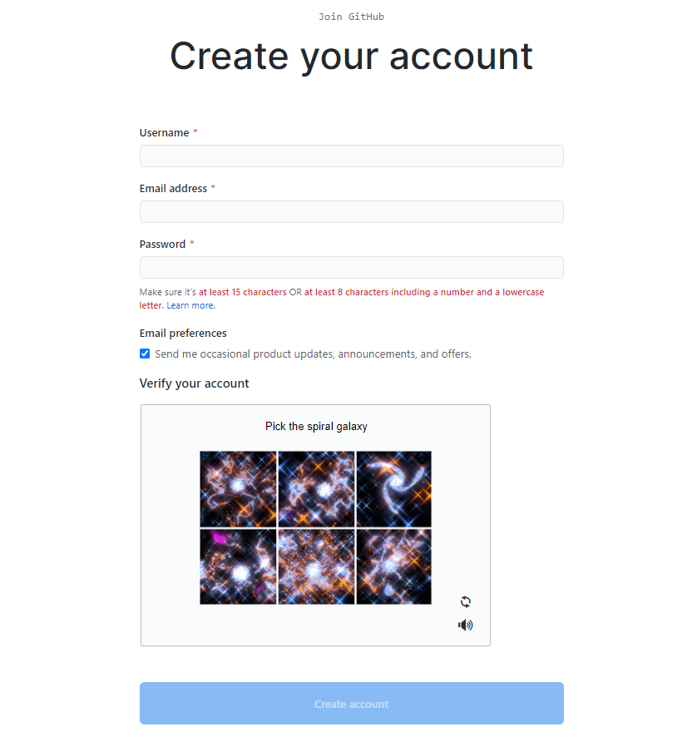

Fill in your details as per the requirement. Like this:

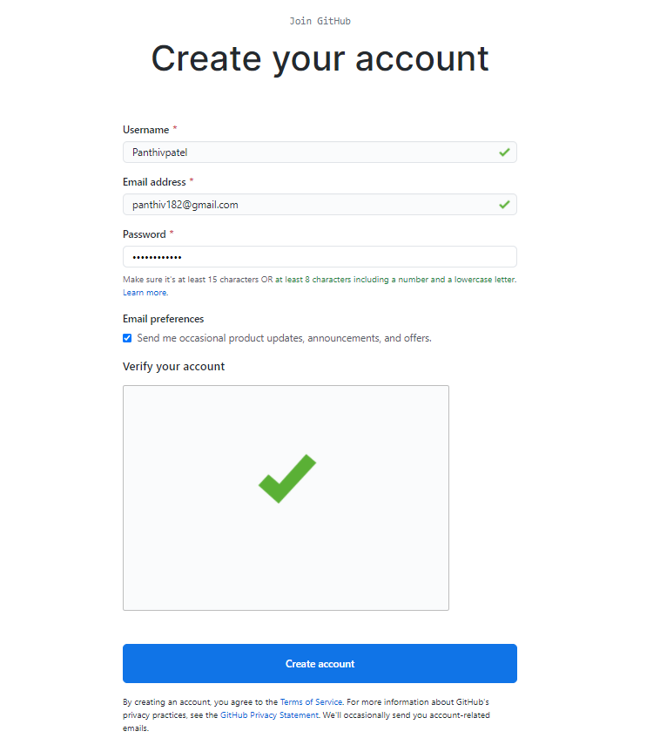

Step 3 : After clicking on create account you will be directed to this page:

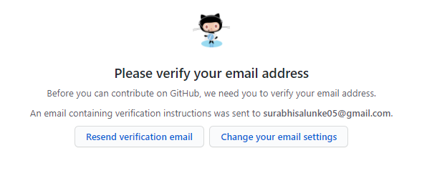

Step  4: Check your email for a verification mail from GitHub

The email will look something like this:

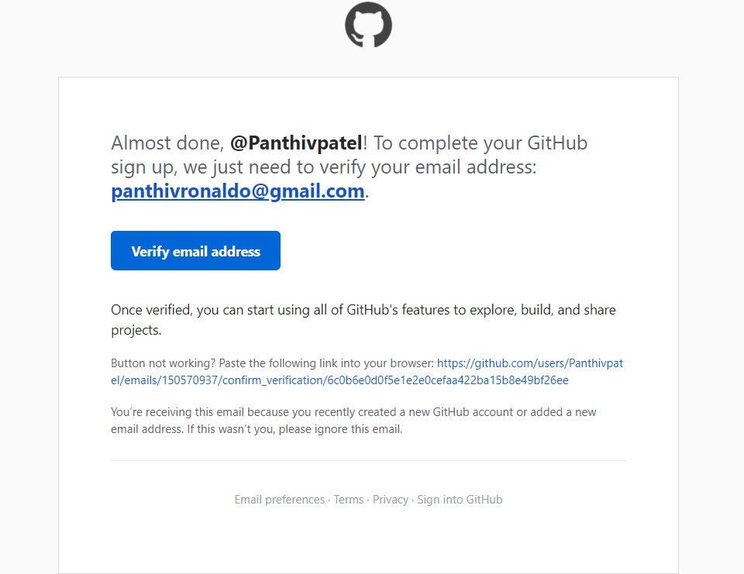

Step 5: Click on verify email address it will take you to this page:

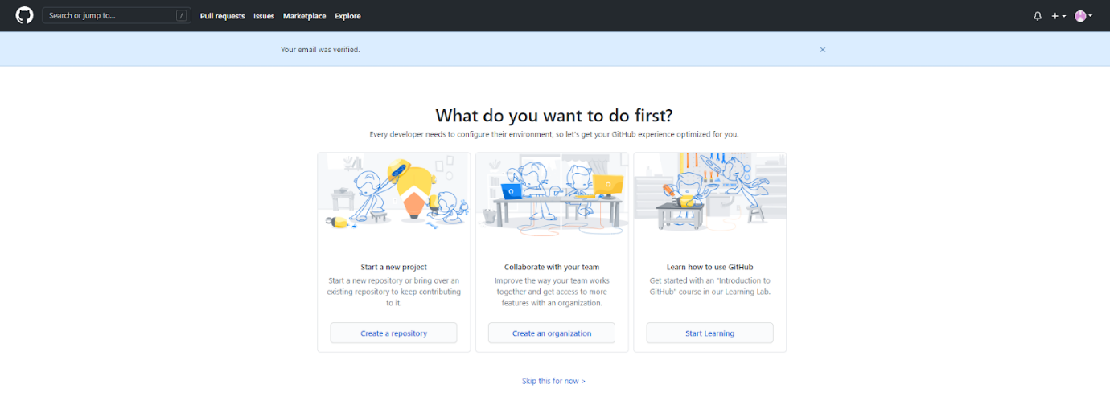

Step 6: to create a repository

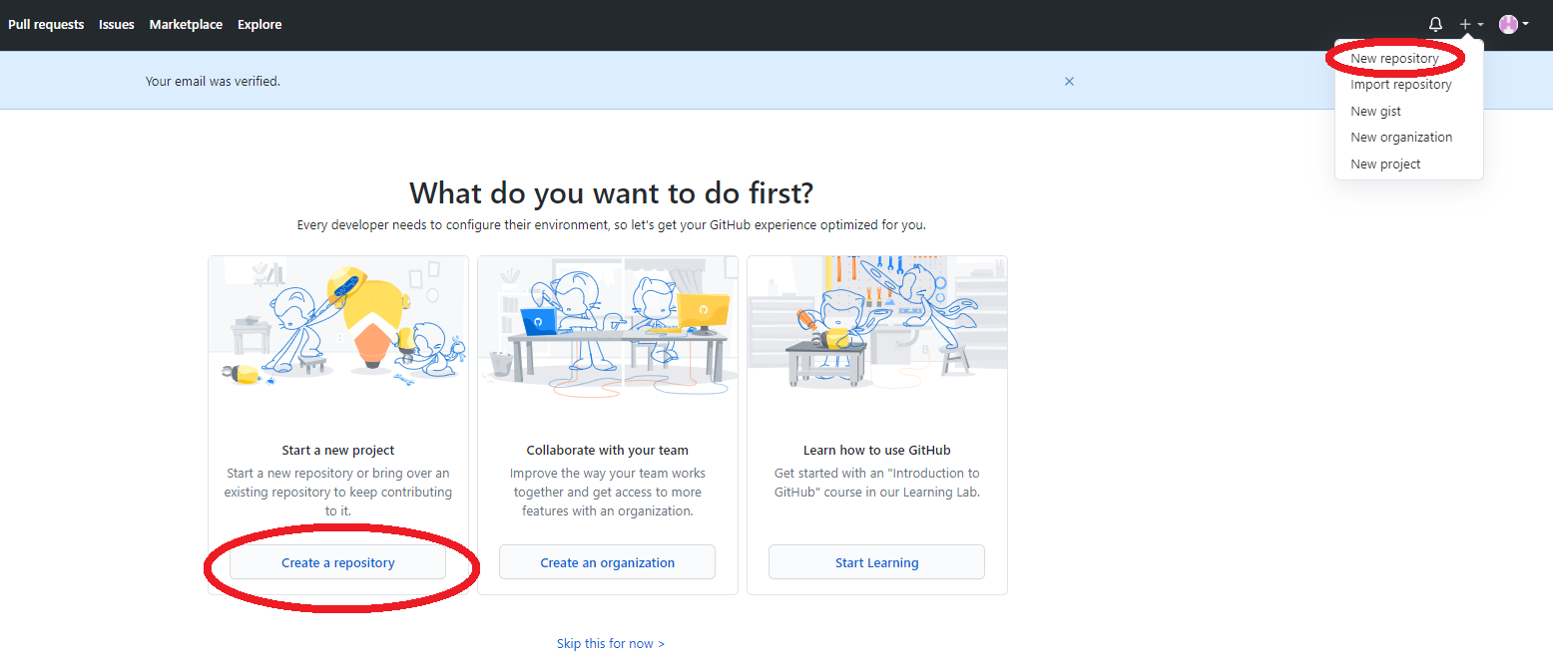

Step 7: fill in the information shown according:

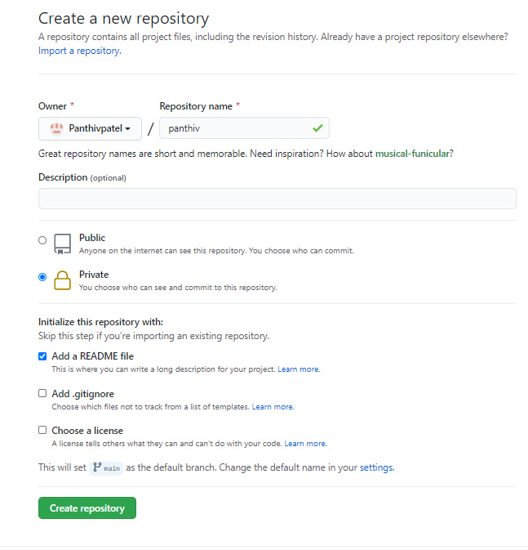

Step 8: you will see your repository on your account

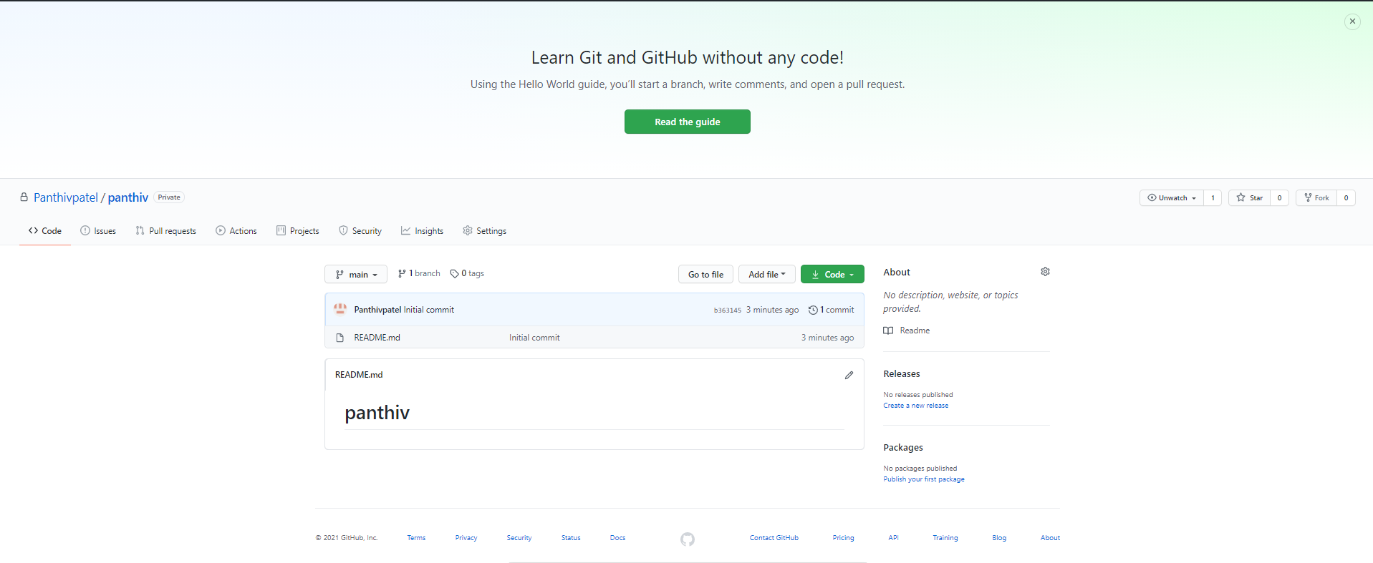

Step 9: to clone the repository click on the green color code button:

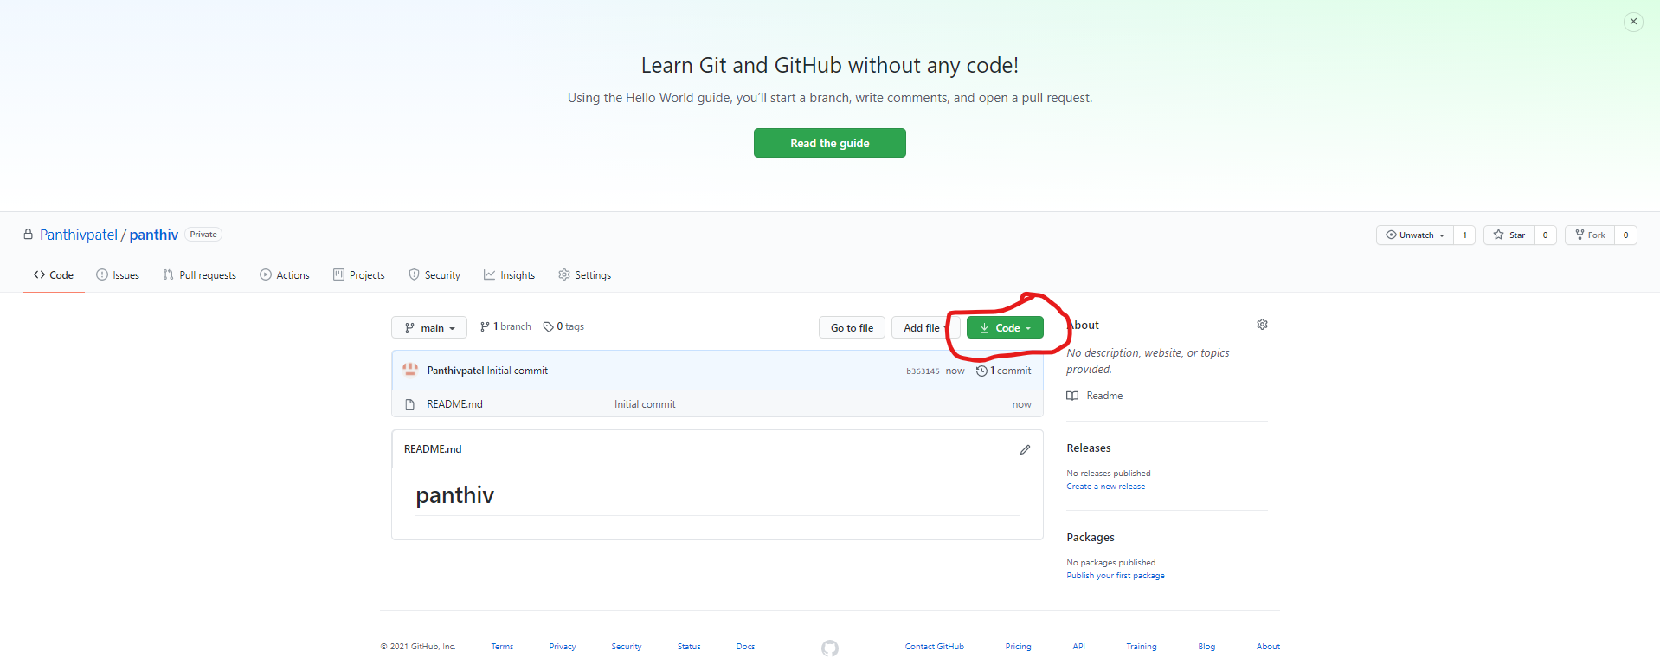

Step 10: copy the url by clicking on the small clipboard icon:

